Day 3 – Assignment(Batch 1 – Block chain)

1. Experiment with Anders blockchain.
Ans:
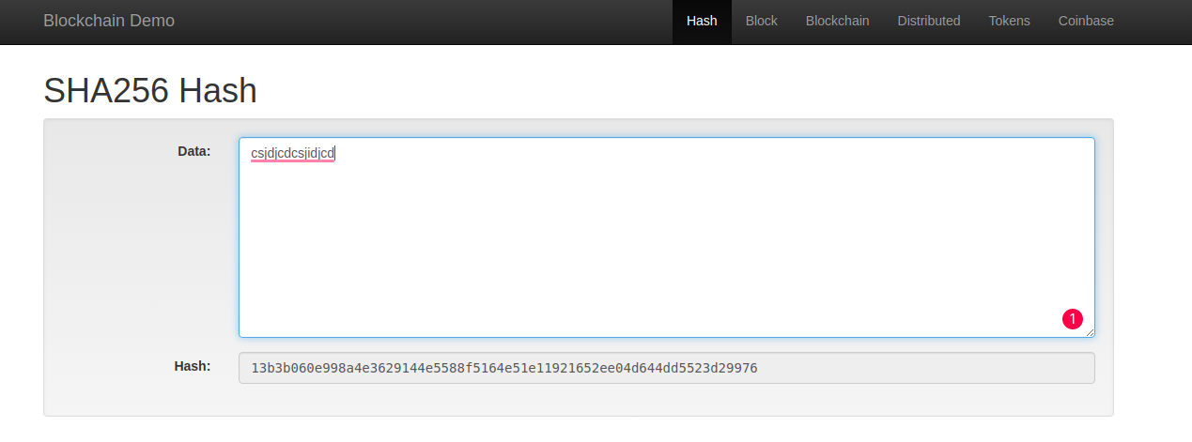
Hash

Block:

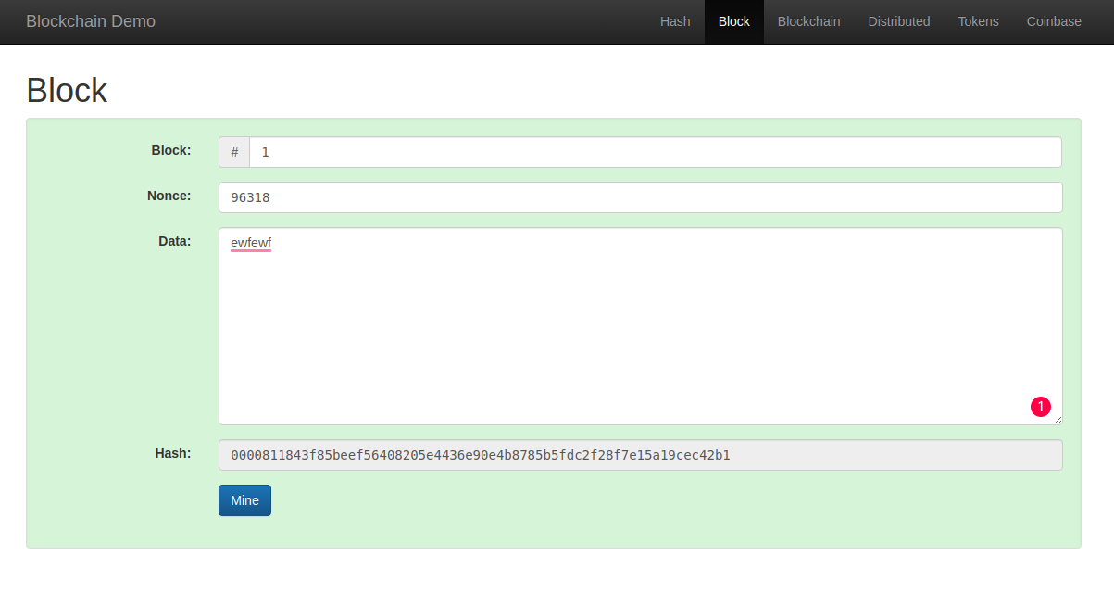

BlockChain

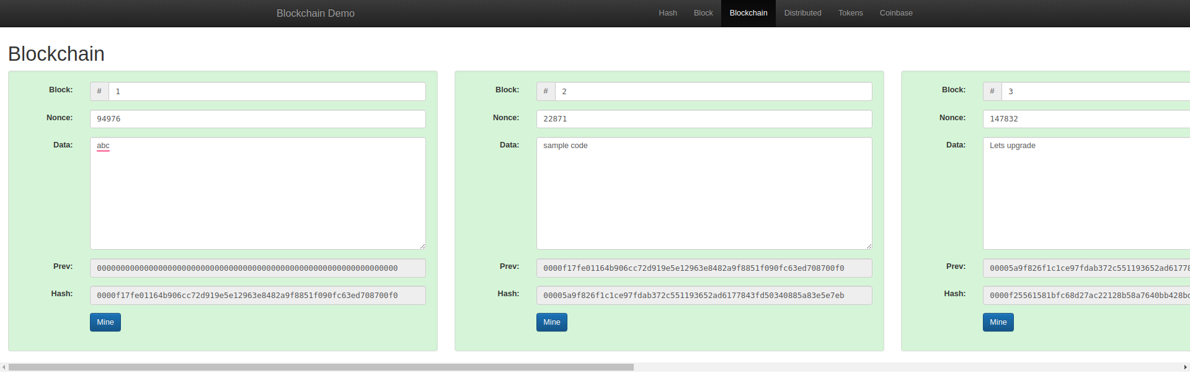
Distributed BlockChain

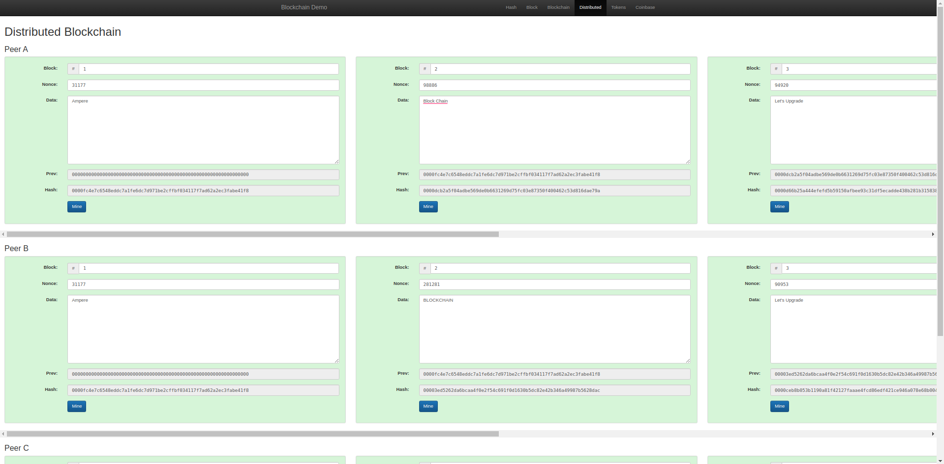

2.

